AAMC POST FLIGHT DIRECT REQUIREMENTS:

images collected in flight..map them with the gps location where the aircraft was and skew the image in horizontal plane. PPR3 is a box where the flights moves.They have an XML header.

Interface with Dr. Qi's project – Milestone!

Plug in SSD

Find the data

Click on the correct data set

Puts the images on the Esri basemap

Requires camera info

must satisfy lan's needs.

Things needed to fly the plane: altitude, drone..Current s/w is dying cuz not being updated. Get data from servers to https for better security. – How to get this? Ask Jo!!

Technologies ised: Java, SDK

Tasks to do: Rescope

1. Pre mission

2. Post mission

Based on what camera u use, the image u capture.

**Code snippets**

Setting the image:

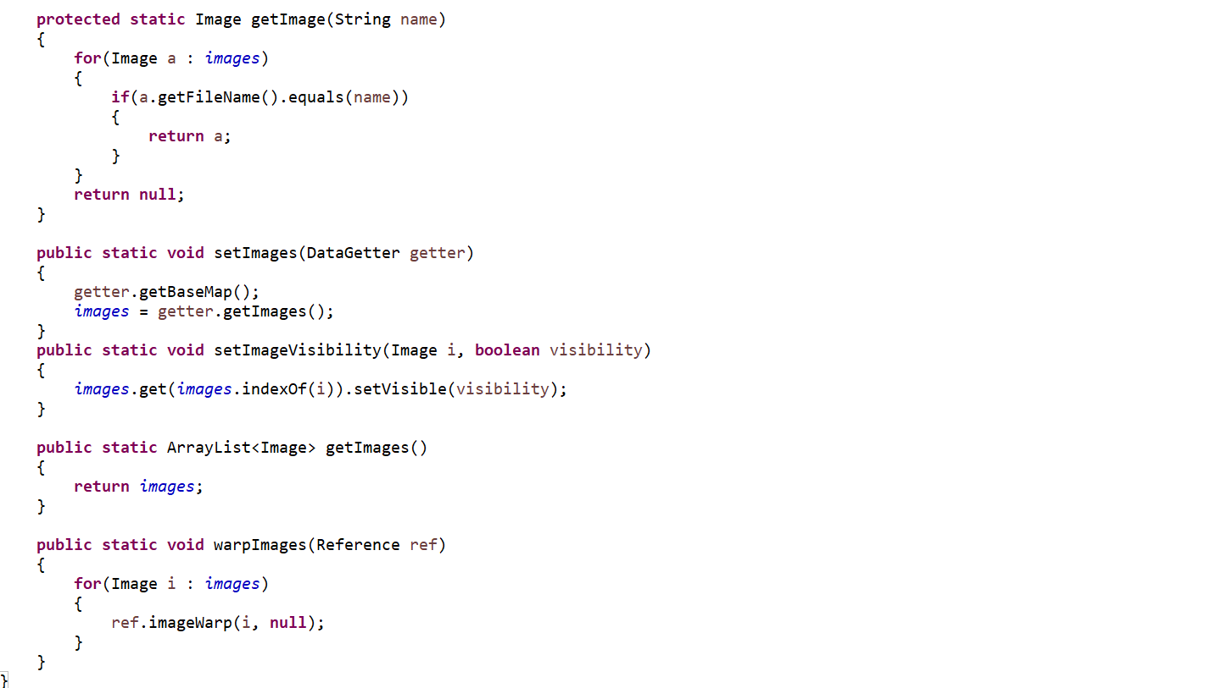

Capturing the image of the plane in horizontal view:

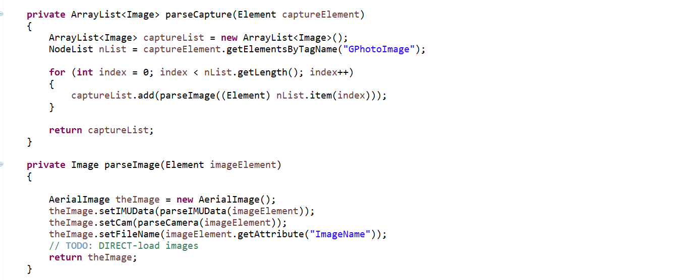

Camera

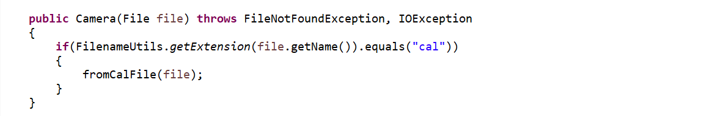

Elevation:

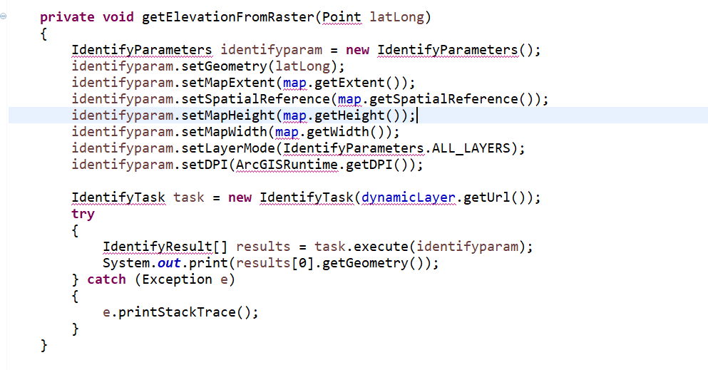

Pre Flight:

Generate Waypoins, Flight lines, and Survey Areas.

Draw them on ESRI map.

Generate boundaries and draw them.

Import/Export to the following formats of XML(import optional)

PPRZ

KML(and convert to KMZ)

FPL

The ability to save.

The ability to edit waypoints (and thus flightlines and survey areas) graphically and textually.

Origin point(Zoom in)

Area of study.

Zoom to area on import

Ground Elevation

Change flight altitude.

Setup the pre flight code on laptop.

Milestones: Did not setup ESRI Account.

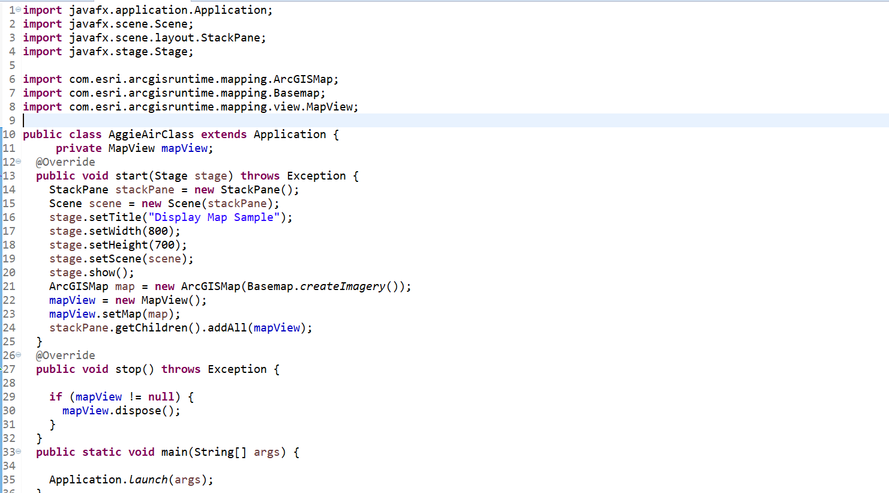

Load flight image:

